UPPER EAST FORK WHITEWATER RIVER WATERSHED MANAGEMENT PLAN
RANDOLPH, UNION & WAYNE COUNTIES, INDIANA
DARKE & PREBLE COUNTIES, OHIO

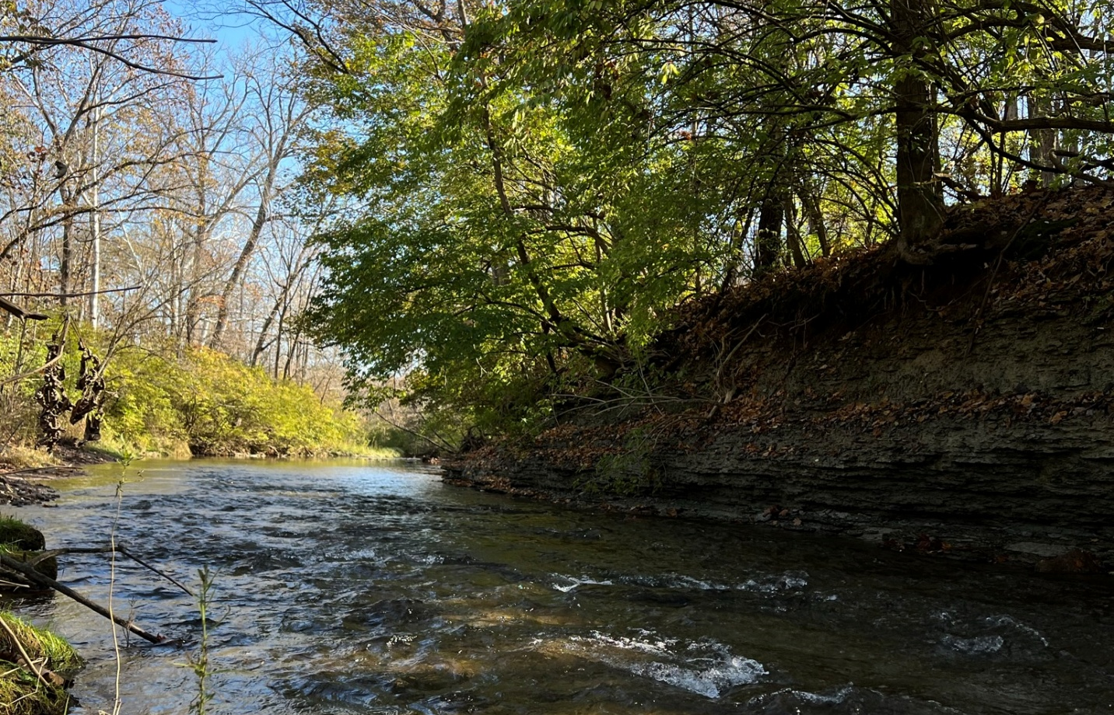

A PROJECT OF THE
WAYNE COUNTY SOIL AND WATER CONSERVATION DISTRICT
823 S. ROUNDBARN ROAD
RICHMOND, INDIANA 47374

SARA PEEL, CLM
ARION CONSULTANTS
PROJECT COORDINATOR
1610 N. AUBURN STREET
SPEEDWAY, INDIANA 46224

UPPER EAST FORK WHITEWATER RIVER WATERSHED MANAGEMENT PLAN
RANDOLPH, UNION & WAYNE COUNTIES, INDIANA
DARKE & PREBLE COUNTIES, OHIO

1.0 WATERSHED INTRODUCTION 1
1.1 Watershed Community Initiative 1
1.2 Project History 3
1.3 Stakeholder Involvement 4
1.4 Public Input 5

TABLE OF FIGURES

Table 1. Upper East Fork Whitewater River Watershed steering committee members and their affiliation. 5
Table 2. Stakeholder concerns identified during public input sessions, steering committee meetings and via the watershed inventory process. Note: The order of concern listing does not reflect any prioritization by watershed stakeholders. 6

TABLE OF TABLES

Table 1. Upper East Fork Whitewater River Watershed steering committee members and their affiliation. 5
Table 2. Stakeholder concerns identified during public input sessions, steering committee meetings and via the watershed inventory process. Note: The order of concern listing does not reflect any prioritization by watershed stakeholders. 6

UPPER EAST FORK WHITEWATER RIVER WATERSHED MANAGEMENT PLAN
RANDOLPH, UNION AND WAYNE COUNTIES, INDIANA
DARKE AND PREBLE COUNTIES, OHIO

WATERSHED INTRODUCTION

Watershed Community Initiative
A watershed is the land area that drains to a common point, such as a location on a river. All of the water that falls on a watershed will move across the landscape collecting in low spots and drainageways until it moves into the waterbody of choice. All activities that take place in a watershed can impact the water quality of the river that drains it. What we do on the land, such as constructing new buildings, fertilizing lawns, or growing crops, affects the water and the ecosystem that lives in it. A healthy watershed is vital for a healthy river, and a healthy river can enhance the community and help maintain a healthy local economy. Watershed planning is especially important in that it will help communities and individuals determine how best to preserve water functions, prevent water quality impairment; and produce long-term economic, environmental, and political health.

The Upper East Fork Whitewater River Watershed drains portions of Randolph, Union and Wayne Counties, Indiana and Darke and Preble Counties, Ohio (216 square miles) and includes portions of one 10-digit HUC (0508000307). The watershed contains a mix of agricultural row crops and pastureland (58%), natural land uses (forest, wetland, grassland; 24%) and urban land uses (17%;Figure 1). The communities in and around the UEFWW watershed are pervasively disadvantaged by low income, with the City of Richmond reporting a 19.4% and Wayne County reporting a 15.9% poverty rate in 2021 according to the Census Bureau. The Climate and Economic Justice Screening Tool identifies numerous disadvantaged community impacts within the City of Richmond including low life expectancy, heart disease, asthma, and diabetes; percent living below the poverty level; lead paint; energy costs; lack of indoor plumbing; and proximity to risk management plan facilities. The Upper East Fork of the Whitewater River Watershed begins in southwestern Darke County, Ohio, northwestern Preble County, Ohio and southeastern Randolph County, Indiana and flows generally south into Wayne County, Indiana. Tributaries include Middle Fork East Fork Whitewater River, West Fork East Fork Whitewater River, Lick Creek, Elkhorn Creek, Clear Creek, Short Creek, Smith Creek, Mud Creek, Boston Creek, Little Creek and others. The Middle Fork Reservoir, which provides drinking water to the City of Richmond, is located north of Richmond. The East Fork Whitewater River empties into the Brookville Reservoir. The Whitewater River carries water south and east from Brookville, Indiana joining the Great Miami River south of Harrison, Ohio (Figure 2).

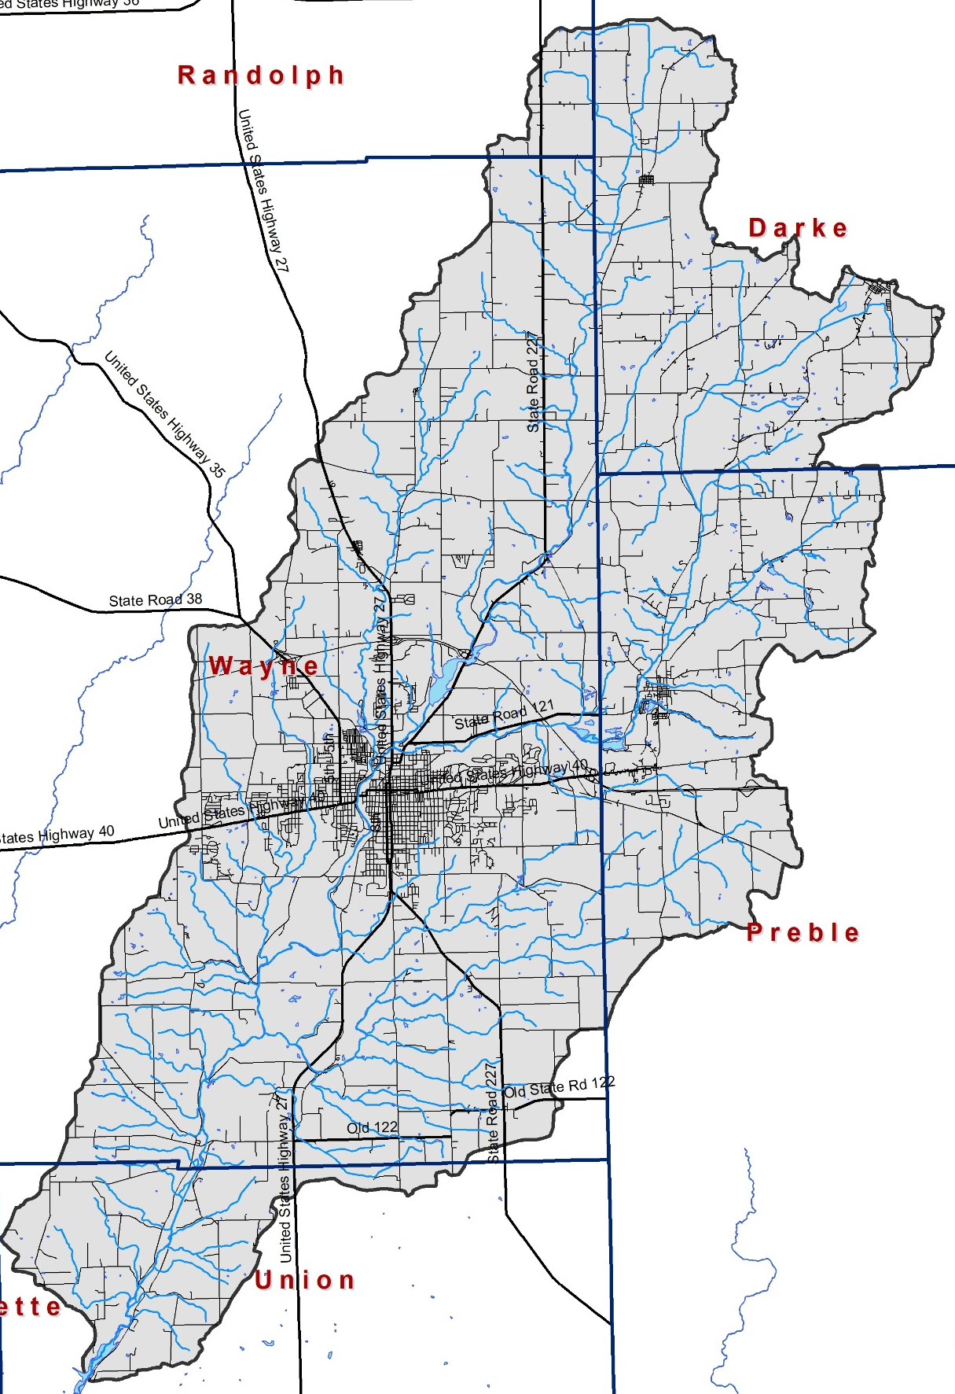
Figure 1. The Upper East Fork Whitewater River Watershed.

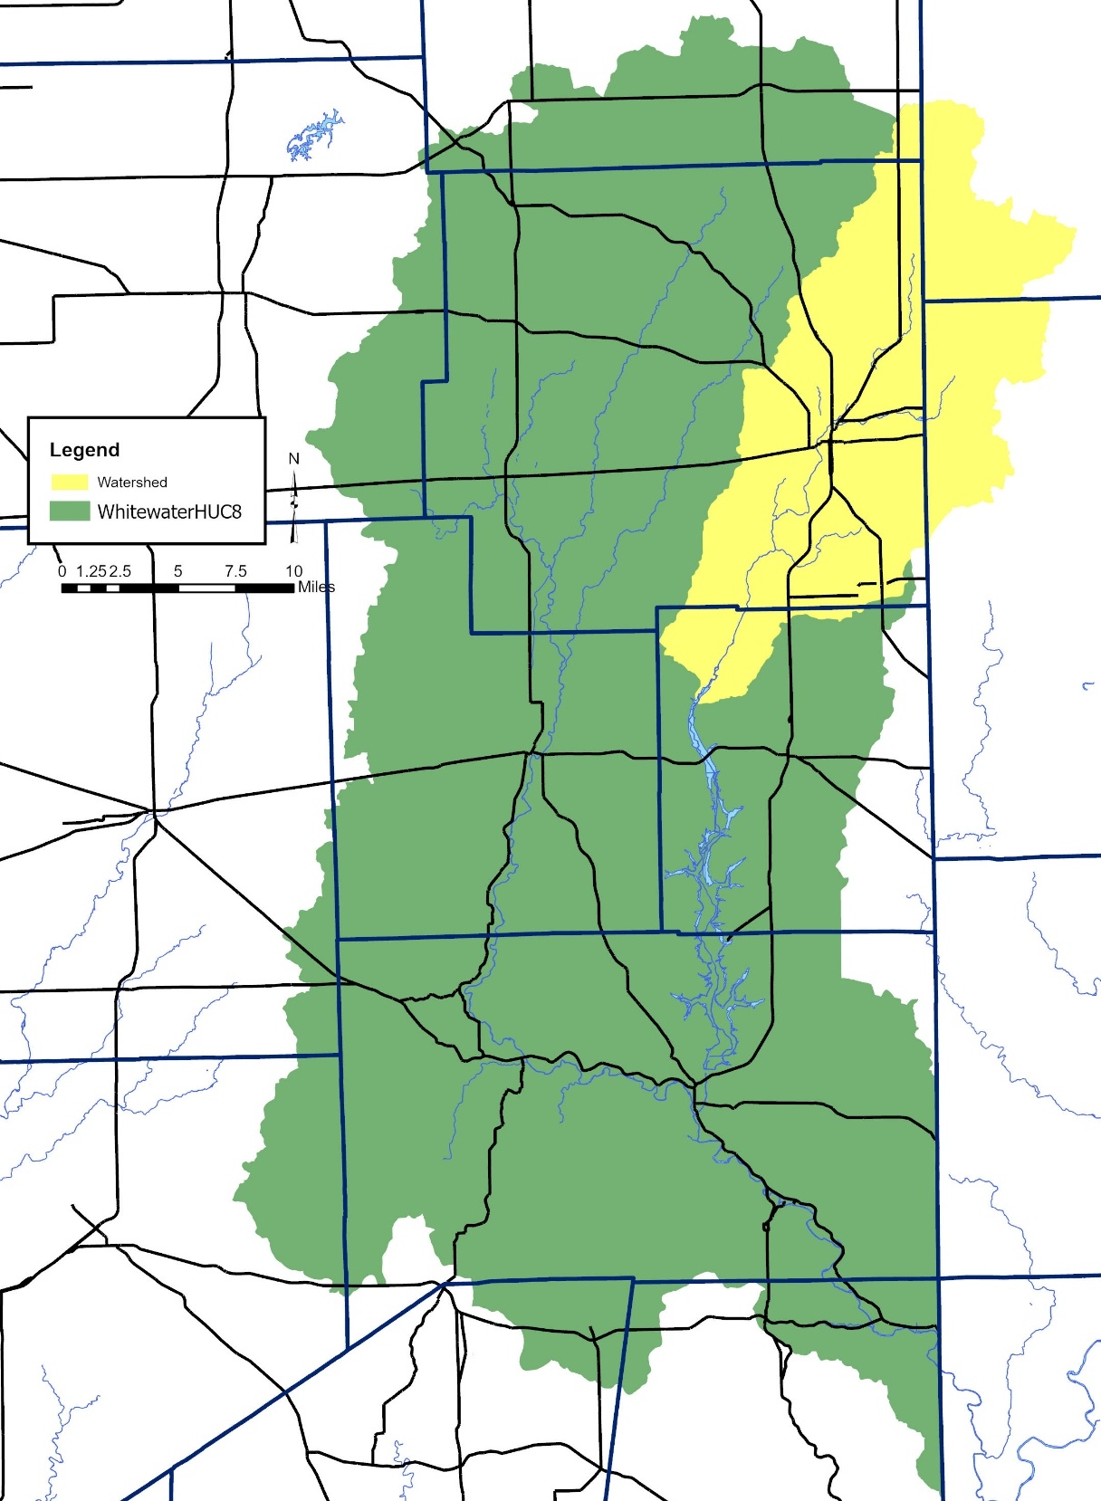
Figure 2. The Whitewater River Basin highlighting the Upper East Fork Whitewater River Watershed.

Project History
The Wayne County SWCD and partners have actively committed to improving water quality in the Whitewater River for nearly 30 years. Wayne SWCD was awarded a LARE grant for the Middle Fork Watershed focused on the Middle Fork Reservoir. A watershed coordinator was hired in 2000 and worked through 2004 to build public awareness and subsequently, the Wayne County SWCD received a 319 grant to fund further work in the Middle Fork Watershed. A plan was completed in 2004 with implementation focused in this area from 2004 to 2006. The 2005 Middle Fork of the East Fork of the Whitewater River WMP focused on the 50 square mile Middle Fork Reservoir Watershed noting that the health of the reservoir was vital as it provides more than 50% of the City of Richmond’s drinking water. Monitoring completed as part of the plan noted elevated sedimentation rates; high E. coli, nutrient and atrazine levels; high nutrient levels causing algal blooms in the river and reservoir; watershed flooding and lack of natural habitat. The West Fork of the Whitewater became the focus of the Wayne SWCD after that time.

The 2017 Whitewater biological assessment completed by Ohio EPA notes that 20 of 22 sample sites in Darke County, Ohio rate as fully supporting for their aquatic life use designation with marginally good to exceptional ratings overall. Nutrient levels were rated as low risk with nutrient enrichment noted as a concern especially in areas of the watershed where agricultural land uses dominate and coincide with historic stream channelization. Elevated daytime DO levels were noted throughout the summer with minimum DO exceedances (low concentrations) observed in the late summer. All streams are noted as impaired for recreational use with E. coli geomeans exceeding targets at 13 of 17 sample sites despite WWTP effluent E. coli concentrations measuring low during the assessment period. Ohio EPA notes that poorly performing septic systems and unsewered communities as well as livestock producers, livestock access and CFO/CAFOs may be impacting E. coli levels.

Based on data compiled as part of the 2004 WMP, 2007 TMDL, 2017 OEPA assessment and in previous and subsequent sampling and assessment efforts, nutrients, sediment, and E. coli are the primary nonpoint source concerns in the UEFWW Watershed streams. The EFWW TMDL (2007) noted that IDEM identified E. coli concerns in the EFWW Watershed as early as 2002. The TMDL identified CSOs, SSOs, NPDES facilities, wildlife, failing septic tanks, smaller livestock operations and CAFOs as sources of E. coli and noted the presence of compliant confined feeding operations (CFOs) and wastewater treatment plants (WWTPs).

More than 50 miles of UEFWW streams in Indiana are impaired for E. coli, while more than 27 miles are impaired for PCBs in fish tissue and the 161-acre Middle Fork Reservoir is impaired for taste and algae problems. An additional four segments of the UEFWW in Ohio are listed for E. coli and siltation impairments. Based on these impairments as well as continued drinking water concerns, the Wayne County SWCD worked with partners throughout the watershed in 2023 to form a preliminary group focused on obtaining watershed management planning grant funds.

Stakeholder Involvement
Development of a watershed management plan requires input from interested citizens, local government leaders, and water resource professionals. These individuals are required to not only buy into the project and the process but must also become an integral part of identifying the solution(s) which will result in improved water quality and addressed water quantity concerns. The Upper East Fork Whitewater River Project will involve stakeholders in the watershed management planning process through a series of public meetings and education and outreach events including workshops, field days and youth-focused education events.

Steering Committee
Individuals representing the towns and counties within the watershed, environmental groups, natural resource professionals and private citizens comprised the steering committee. The steering committee had its first meeting on May 20, 2025. Table 1 identifies the steering committee members and their affiliations.
Table 1. Upper East Fork Whitewater River Watershed steering committee members and their affiliation.
Individual | Organization(s) Represented
Bryan Day and Shannon Hayes | Earlham College
Sarah Mitchell | Economic Development Commission, Wayne County
Jia Xue and Hunter Jacosky | Indiana University East
Rich Nicholson | Friends of the Middle Fork
Ted Gilman | Local resident
Chris Daniel, Darla Paul | Indiana American Water
Manuel Mercado Garcia | NRCS
Brad Kramer, Kyle Cross, Tony McWhinney | Preble County Engineers office
BJ Price | Preble County Land Use Management
Julie Borgmann | Red Tail Land Conservancy
Peggy and Duane Hieger | Local residents
Pat Smoker, Leighanne Hahn, Elijah Welch | Richmond Sanitary District
Jessica Foster | Richmond MS4 Coordinator
Liz Yetter | SICIM
Brian Schlepper | Wayne County Foundation
Chad Kircher | Wayne County Health Department
Gordon Moore, Rob Clark | Wayne County Surveyors office
Jen Brown, Raquel Baker, Luanne Holeva | Wayne County SWCD

Public Meetings
Public participation is necessary for the long-term success of any watershed planning and subsequent implementation effort. One component of public participation for this project will be public meetings. The purpose of the public meetings was to provide information on the overall planning effort and its progress; solicit stakeholder input, opinions, and participation; create opportunities for the public to recommend programs, policies, and projects to protect and improve water quality; and build support for future phases of the project.

The public meetings/listening sessions were advertised through press releases, partner email and a Facebook event. The first public meeting occurred on April 29, 2025 and was hosted as a drop in and chat meeting. In total, 35 individuals attended the meeting at which they learned about the project and its components and provided their concerns about the watershed, weighed in on project sample sites and reviewed upcoming events and activities.

The second meeting will occur in year two of the project and will include an update on the status of the project and focused on gathering feedback on critical areas, practices selected for implementation and the likelihood of meeting project goals gathered.

Public Input
Throughout the planning process, project stakeholders, the steering committee, and the general public listed concerns for the Upper East Fork Whitewater River Watershed including the East Fork Whitewater River, its tributaries, and its watershed. Public and committee meetings were the primary mechanism of soliciting individual concerns. All comments were recorded and included as part of the concern documentation and prioritization process. Concerns voiced throughout the process are listed in Table 2. Similar stakeholder concerns were grouped roughly by topic and condensed by the committee. The order of concern listing does not reflect any prioritization by watershed stakeholders.

Table 2. Stakeholder concerns identified during public input sessions, steering committee meetings and via the watershed inventory process. Note: The order of concern listing does not reflect any prioritization by watershed stakeholders.
Stakeholder Concerns
Water conservation is needed
Riparian restoration and conservation are needed
Water quality impacts to peoples' health and wildlife
Access to local resources should be preserved and improved
My kids play in the river, concerned if it is safe
Recreation use impairments/safety concerns
Clean drinking water supply
Middle Fork Reservoir pollution impacting the City of Richmond water supply
Dairy farm impacts (noted farm on Smyrna at 277 just south of I70)
Agricultural runoff impacts to soil and water
Water quality is poor
Recreational development could threaten important habitat (Cerulean warbler nesting site near SPUR trail)
Invasive species impacts to riparian corridor
Brookeville Reservoir signs regarding recreational contact limitations - is it safe to swim, boat or eat the fish?
Drinking water protection is needed
Runoff from nutrients or plant protection products
Excess sediment and nutrients in the water
Streambank erosion
Trash and other pollution
Ecological preservation and restoration is needed
Manage invasive species
Clean up trash along the river
Mitigate environmental impacts only with geographically appropriate native plants
Maintain and improve public access to the river
Increase opportunities for/enhance recreational opportunities
Make Richmond a tourism destination
Harsh regulations
Sewer overflows
Trash
Excess nutrients cause toxic algal blooms in the Middle Fork Reservoir
Atrazine
E. coli levels are high
Sediment accumulation in the Middle Fork Reservoir
E. coli present throughout the watershed
Combined sewer overflows
Logjam (Greenway near Flatly/Tingher)
Logjam (Springwood at Waterfall Road)
Historic impact of Springwood Lake (superfund site?)
Lead and heavy metal impacts in Springwood Lake sediments/Whitewater River sediments
Boston Creek and Elkhorn Creek areas are beautiful, maintain/improve these areas
Taste and odor issues Middle Fork Reservoir
Algal blooms at Middle Fork Reservoir
Concerns about water quality in the water quality in northeast watershed
Legal drain maintenance
Source water protection
Flooding, floodplain management
Sources of E. Coli
Cyanotoxin levels and their history – how have levels changed over time?
Brookville Reservoir water quality issues – how much impact does the Upper East Fork of the Whitewater have on Brookville Reservoir

