2016

Lee, Zachary

USDA

5/27/2016

Watershed Newsletter:

Issue 5

Urban Pollution and its Impact on Water Quality

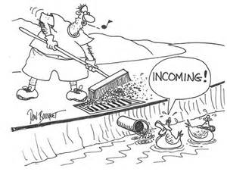

**Introduction:**

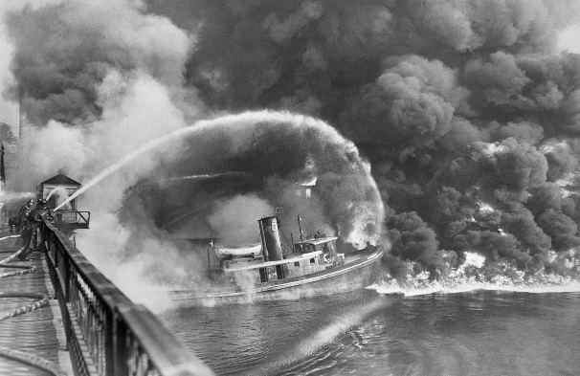When people think about urban pollution they think of smokestacks releasing carbondioxide into the atmosphere or a factory dumping a chemical liquid down the river. This type of pollution used to be a regular occurrence before the government made a department called the Environmental Protection Agency or EPA. The main goal for the EPA is to protect our natural resources for future generations. Before the EPA, there were many problems with the water quality of our rivers and streams. One river called the Cuyahoga River ignited on fire because it was so polluted. After the Cuyahoga River Fire and other river fires, the U.S. Government created the Clean Water Act. This bill helped reduce the number of industrial pollutants migrating their way through our rivers and streams, but there are still other hidden dangers that are impacting our rivers and streams.

The EPA and other environmental government agencies are trying to stop these hidden dangers called non-point source pollutants. Nonpoint source pollutants come from a source that we cannot point to the exact location it is coming from. It is hard to combat these type of pollutants because they impact our environment every day and people are not aware of this problem. In this newsletter, we will discuss ways we can stop and/or reduce these pollutants in an urban setting.

**Storm and Sewer Systems:**

In a city, there are two different systems called a Stormwater System and a Sewer System. A Sewer System is a system of pipes that help transport your wastewater from your house to a Wastewater Treatment Plant. At the Waste Water Treatment Plant the wastewater gets cleaned and released back into a river, stream, or ditch. The Stormwater System is different because it collects all of the stormwater and goes directly into a river, stream, or ditch. The Stormwater System does not go into a Wastewater Treatment Plant to get cleaned. This is problematic, because whatever goes into the storm drains will come out exactly the same. If we have pollutants or dump hazardous chemical down the storm drains it can cause many problem for our surface waters and our environment.



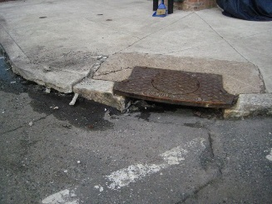**Sediment:**

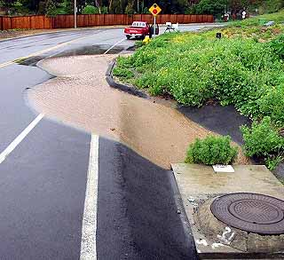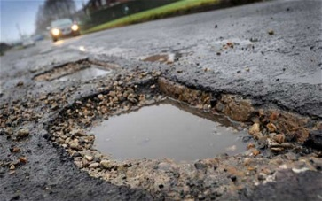Sediment is the most prevalent nonpoint source pollutant in the world and it can cause a variety of problems for an aquatic habitat. In the city environment sediment can come from various sources from construction sites to degraded infrastructures, such as roads, curbs, and parking lots. The main problem that sediment produces is turbidity or the cloudiness of water. This is problematic because it increases the temperature of the water. When the water gets cloudy it also gets a darker color. Since the river turns into a darker color it will absorb more solar radiation from the sun and produce heat. The same thing happens when you wear a dark shirt on a sunny day. This interaction causes the amount of life in the water to go down because most aquatic organisms like to live in cool water. Another problem that sediment can pose is that it can carry other contaminants with it such as, car fluids, fertilizer, and pesticides that could cause even more harm to the environment.

**How can we stop sediment from going into our rivers and streams?**

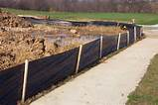There are many ways to keep sediment in place or reduce the amount of sediment moving into our rivers and streams. In most cities you will see a street sweeper. This is the best way to collect sediment off of the streets and dispose of it in a safe location. The city can also help reduce the amount of sediment in our streets by keeping the infrastructure in good condition and that includes keeping up with potholes, curbs, and sidewalks. Protecting our infrastructure will not only help with our water quality, but also keep a safe environment for citizens. Construction sites are the biggest movers of sediment. The construction companies battle this by implementing a silt fence or a black fence around the work site, but if they do not implement this right sediment will escape through the construction site. The last thing people have to be aware of is to keep their storm drains clean because whatever is around your storm drain will eventually make its way into the river. An untidy storm drain can also become clogged and can pose a hazard for drivers.

**Nutrients:**

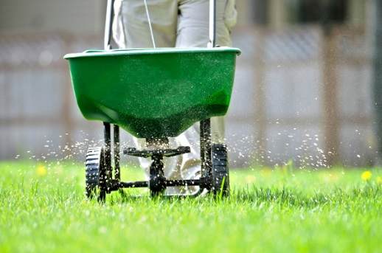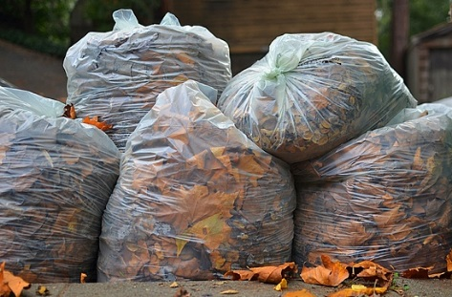People tend to blame the excess nutrients and pesticides on farmers, but people from the city might be contributing to this problem. A farmer has hundreds of acres of land that he needs to fertilize and apply pesticides. The farmer is not going to use excessive amounts of fertilizer and pesticides because it would be too costly. A person that lives in the city might over apply because he/she wants to use the whole bag that they bought, instead of using the recommended rates, because they think more will be better. Pets and animal waste can also contribute to the excess amounts of nutrients in our rivers and streams. Pet waste not only carries nutrients, but it can also carry harmful bacteria like E. coli. Another source of nutrients is leaves. As they decay, they release a nutrient called phosphorus. When you are picking up your leaves make sure you put them in a trash bag. These nutrients are a problem because they can cause algal blooms, which is a concentrated amount of algae in one area. It is problematic because it can lower the amount of oxygen in the water, which can result in fish kills. Pesticides can also wreak havoc on aquatic organisms and amphibians. Atrazine is one of the most widely used pesticides in the Mississippi River Watershed. Atrazine is a type of herbicide that kills broad leaf plants that will actually turn some frogs into hermaphrodites and can also kill other amphibians. Amphibians are the most impacted with pesticides and other chemical agents because their skin is permeable meaning that chemicals and other harmful things can be absorbed through their skin. This is can cause a cascade effect through the food chain, so the pesticide you might be using could actually end up on your dinner table.

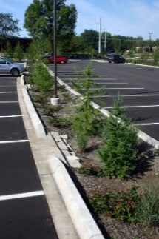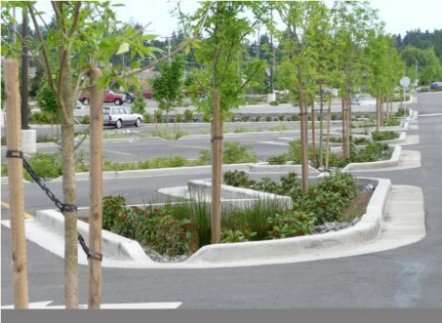**How do we reduce the number of nutrients and pesticides from going into our waterways?**

We can first do the little things, such as picking up our pet's feces. We can also pick up the leaves and put them in a bag for the leaf collection. You can also only use recommended amounts of fertilizer and pesticide only if you desperately need to use them. It would be best if we did not use any fertilizer or pesticides, unless it is for produce. Farmers use fertilizer and pesticides to secure the chance of producing a healthy crop. They rely on their crop production for financial security where a person that just uses these chemicals to have a green, dandelion-free yard is just throwing away money. Your money would be better served planting flowers and other vegetation that will help our native wildlife come back into the city. The city can get rid of storm drains and replace them with bioswales or curb cutouts that are engineered to slow down water and absorb the nutrients and possibly other contaminates that are running off. These practices not only help purify the water as it get soaked up by the soil, but are also aesthetically pleasing.

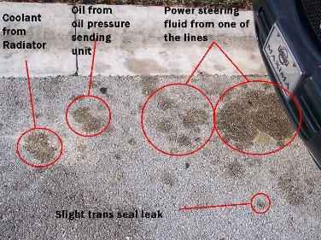**Car Fluids:**

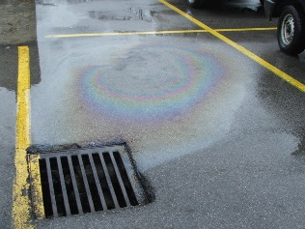Car fluids are a big problem for our environment. At the gas station or parking lot, you will notice a rainbow film of oil on the asphalt. Car fluids can become problematic because the animals could die or become severely sick if they ingest it. The fluids that we see on the street will eventually make it into the river where it can be impact our wildlife.

When you are changing your oil get it done by a mechanic so they can safely dispose of the used oil. When changing your oil or other car fluids at home do it on the grass and not on the concrete, because if you do spill the soil will absorb the fluid and hopefully purify it by the time it reaches the river or aquifer, but the soil can only absorb and purify small quantities, so do not dump your used oil onto the grass. If there is a high concentration of chemicals dumped on the grass it could pollute your drinking water. After you are done changing the oil you can recycle it at Walmart, O'Reilly Auto Parts, Advanced Auto Parts, AutoZone, Firestone, and Tractor Supply. To make sure you are not leaking any car fluids be observant of any new spots in your driveway. If you see sign of a leak take your car to the mechanic immediately.

**Stormwater:**

All of these contaminates use stormwater as a method of transportation due to the abundance of concrete and pavement. We will be able to reduce the number of pollutants by holding or increasing the infiltration of the stormwater. Engineers developed a porous pavement that will allow the water to go directly into the ground, even after a heavy rain. This pavement is very expensive, but in the future, this pavement will likely be used everywhere. Rain barrels are also a good cheap Best Management Practice because they not only help contain the stormwater and they also collect the sediment that is running off of the roof. Rain Barrels allow you to use the water in a variety of ways and slowly release the water back into the environment.

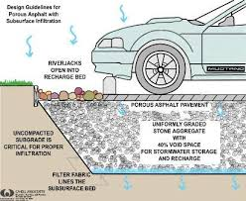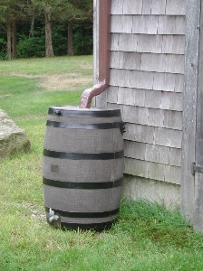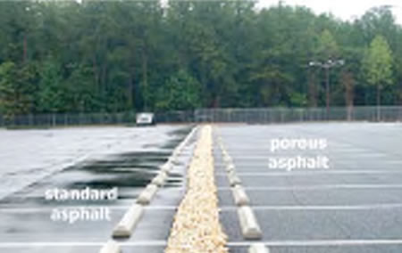

**Conclusion:**

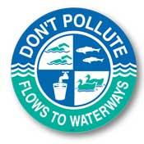 The Best Management Practices that we discussed in this newsletter are only a few from a long list of Urban BMPs that you could implement in your community. The first step to making a real difference is looking at yourself and asking what can I do to help my community and the environment as a whole? The Soil & Water Conservation District and Whitewater River Initiative are implementing Storm Drain Markers to serve as a constant reminder to stop polluting and for you to become aware of the impacts you might have on the environment. If you have any questions or want to volunteer for the Storm Drain Labeling Project and other projects we have on our website at [www.waynecountyswcd.org](http://www.waynecountyswcd.org), or contact Zach Lee, Watershed Coordinator, 765-966-0191 Ext. 3.