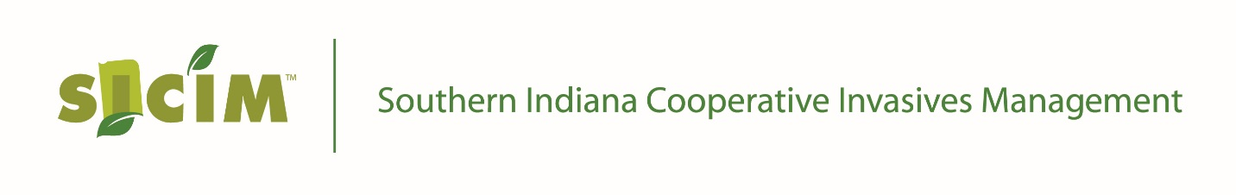
NEWS RELEASE
Media Contact: Will Drews: (812) 882-8210 ext. 3408, Willem.Drews@in.nacdnet.net

NRCS and Invasive Plant Groups Sign Agreement to Work Together
September 20, 2017. As the problem with invasive plants has risen sharply globally, two entities in Indiana have joined forces to stem the rise of these threats to our economy and environment. The Southern Indiana Cooperative Invasive Management (SICIM) group and the USDA Natural Resources Conservation Service (NRCS) have entered into a contribution agreement for the purpose of developing local grass-root organizations called Cooperative Invasive Species Management Areas (CISMAs) throughout Indiana.
Both SICIM and the NRCS have been working for many years to combat invasive plants and raise public awareness of the devastation being caused by these non-native pests, and both have come to the realization that to make headway, the problem needs to be addressed at the local level by local people using local resources.
Troy Hinkle is a board member of SICIM which is a CISMA that spans 35 counties across southern Indiana. There are currently four regional CISMAs in Indiana. All of these CISMAs are operated strictly with volunteers. Hinkle explains SICIM is the oldest and largest of the existing regional CISMAs and will take the lead state-wide. He said, “Under the five-year contribution agreement, NRCS will provide partial funding for SICIM to hire staff who will work with SWCDs and other conservation organizations to develop or enhance CISMAs that cover one or two counties.”
Hinkle envisions SICIM helping these new CISMAs get organized and find the human and financial resources needed to begin effectively combating invasive plants in their communities.
SICIM staff and volunteers will also provide free technical assistance to landowners who want to control invasive plants. Landowners can have their properties surveyed to determine whether non-native plants have invaded their property, and the CISMAs will write management plans for landowners who want to control invasive pests.
Jane Hardisty, State Conservationist with the NRCS is confident that this agreement will bring a needed emphasis to the fight against invasive plants in Indiana. She noted NRCS has put $917,400 into the 5-year agreement. The SICIM group has agreed to raise an equal amount through grants, donations, and contributions from other conservation organizations. Together these $1,834,800 in funds, and the volunteers brought together to work on the invasive problem will be a formidable force which she believes will make a tremendous difference in bringing back the natives and restoring natural habitat in Indiana.
For more information on this agreement contact SICIM at http://www.sicim.info/ or call 812-653-5563.

